Farm Rack UI

A farm rack control UI for 63A farm.

Contents

Introduction 3

Usage 3

Connect to a Rack 3

Turn on a shelf 4

Turn on the light 4

Using scheduled activation 5

# Introduction

The farm UI is capable of controlling each of the 14 racks in the farm.

# Usage

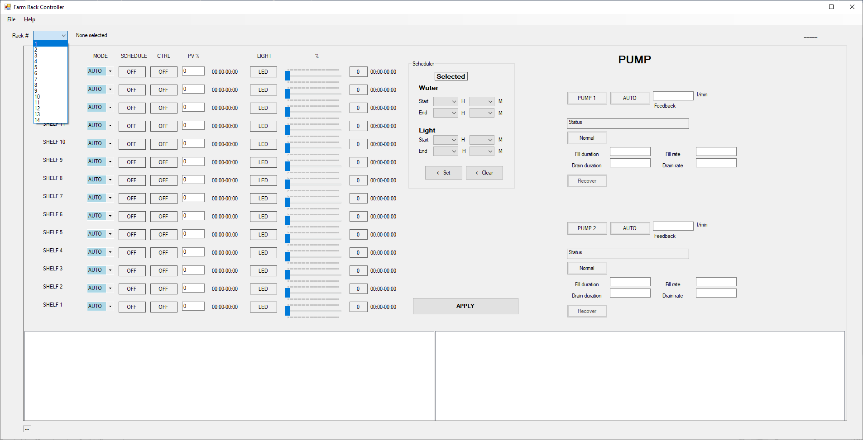

## Connect to a Rack

In order to connect to a rack PLC, select the rack number from the **Rack #** drop down list. It will automatically connect once the rack is selected.

Once connected, all the other actions, eg. Setting valve, light, schedule, pump, etc. will require the user to specifically click **APPLY** to activate the configuration.

## Turn on a shelf

Select a shelf mode and pick **MANU** or **SEMI**

If **MANU** is selected, specify a percentage in the **PV%** input box. **SEMI** mode will auto set the valve % and will not use the user input setting.

Turn **ON** the valve CTRL

Click **Apply**

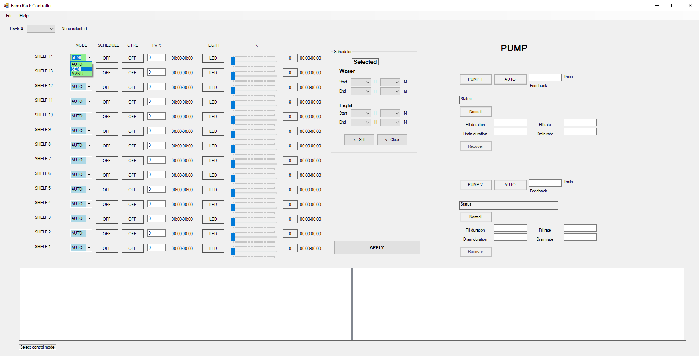

## Turn on the light

Set Mode to **SEMI** or **MANU**

Click the **LED** button to turn on or off

Drag the slider to set the percentage

Click **Apply**

## Using scheduled activation

* Click the schedule time for the specific Valve and/or Light, they will turn Green.
* In the schedule group, set the start and end time for either water or light or both.
* Set Mode to **AUTO**
* Click **<- Set**, the highlighted setting will be updated.
* Click the Schedule **ON**/**OFF**
* Once everything is set, click **Apply**

1.Click to select

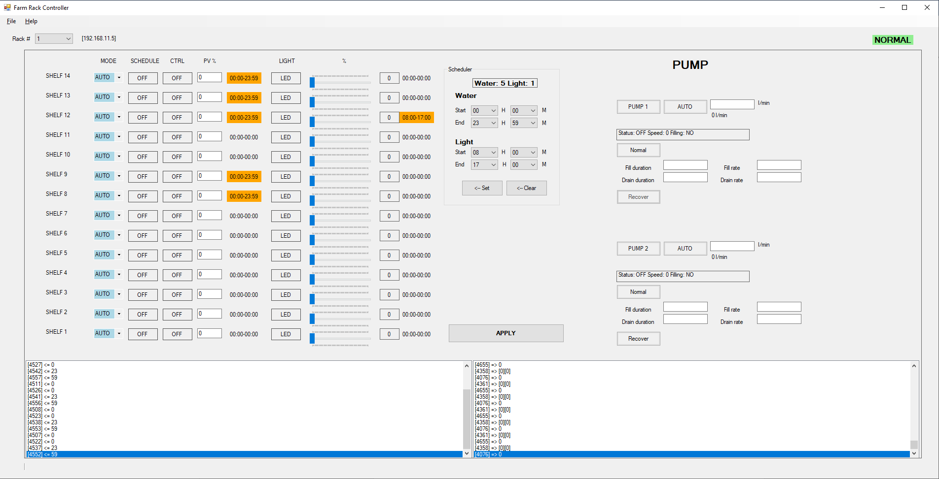

4.Click APPLY

3.Click Set

2.Set schedules here